Suicide Rates Overview

# Information about the data

This compiled dataset was pulled from four other datasets linked by time and place, and was built to find signals correlated to increased suicide rates among different cohorts globally, across the socio-economic spectrum. The data was from year 1985 to 2016. The columns in it including country, year, sex, age group, count of suicides, population, suicide rate, country-year composite key, HDI for year, GDP for year, GDP per capita and generation.

# Summary

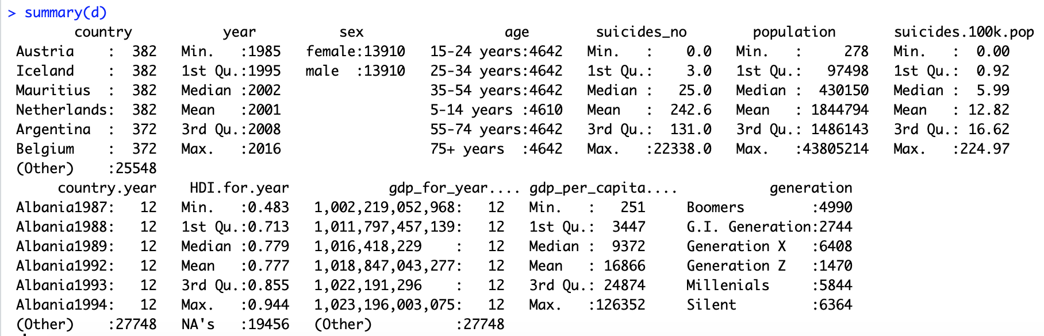

According to the summary, the data is pretty evenly distributed: we have same number of male and female, age groups are also share similar number of people and different countries have about the same sample size. Column “suicides.100k.pop” represent the suicide rate per 100,000 people.

# Questions to ask

**About country:**

1. Of all the countries in this dataset, which ones have the highest & lowest suicide rate



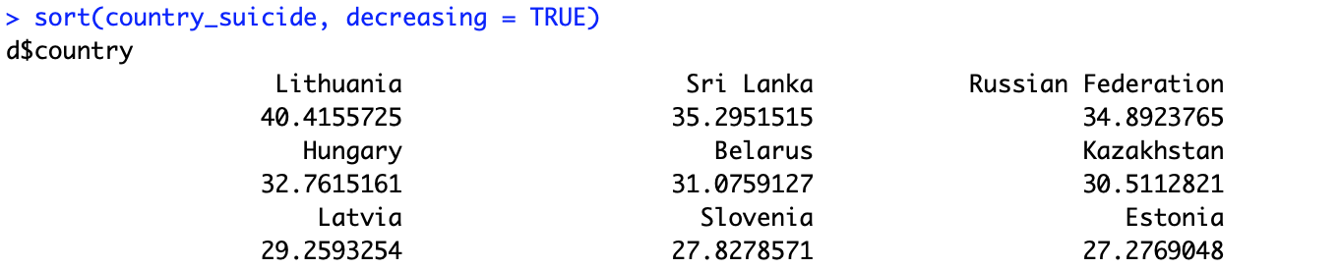

Lithuania Sri Lanka and Russian Federation are the top 3 countries with highest suicide rate of all the countries included in this dataset.

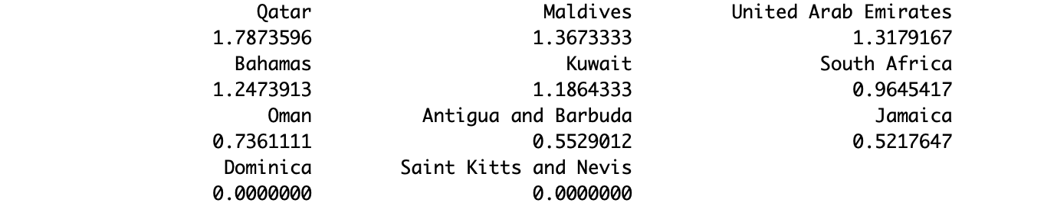

On the contrary, Jamaica, Dominica and Saint Kitts and Nevis has lowest suicide rate. Especially Saint Kitts and Nevis and Dominica show zero suicide rate from 1985 to 2016. After taking a look at the dataset, Dominica and Saint Kitts and Nevis have a relatively much smaller sample size compared to other countries. So I decided to remove them from the dataset.

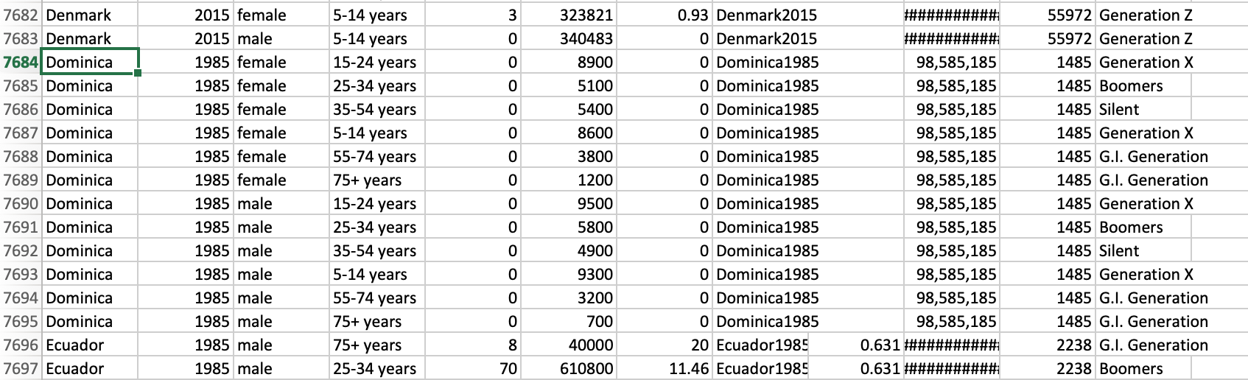

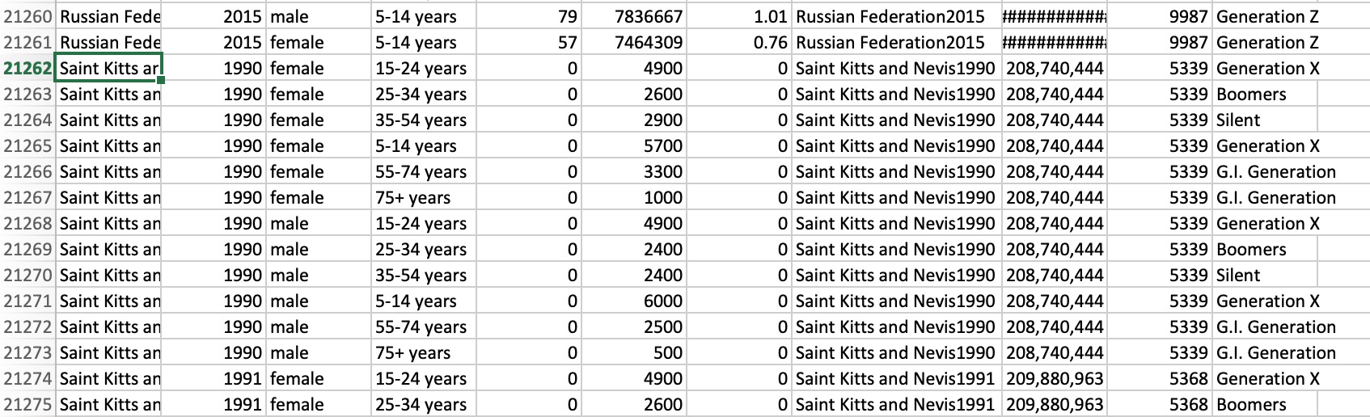

1. Do rich and poor countries have distinct pattern of suicide rate?

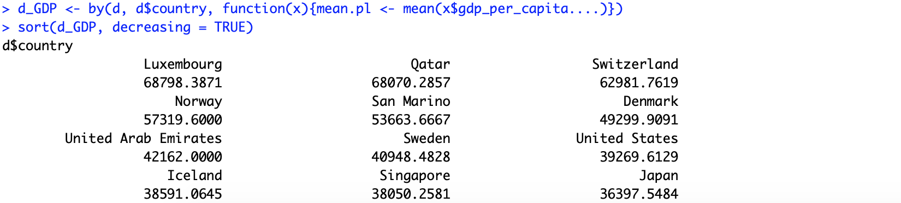

We can see some rich countries have average GDP per capital over 36,000. I also include some poor countries below for comparison purpose:



Then I combine the average suicide rate with GDP per capital for all the countries to analyze the effect of GDP per capital on suicide rates:

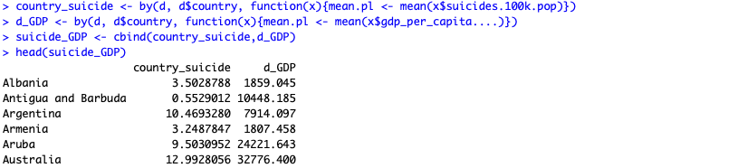

Removed some “NA”s from the data frame:



Reorder them according to average GDP per capital in descending order:

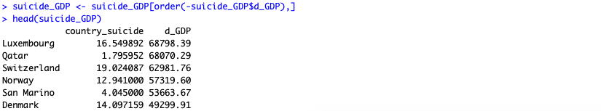

I picked top 10 countries to represent Rich and bottom 10 to represent Poor, ran Kruskal.Wallis test on them to see if degree of wealth for the country would have effect on suicide rate:



P-value shows insignificant, so we can conclude that the difference of suicide rate between rich countries and poor countries is not significant, so that we can’t compare them.

**About age:**

1. Which age group has the highest suicide rate



For the whole dataset, it appears that suicide rate has the positive correlation with age. As age increase, suicide increase accordingly, the highest is age group above 75-year old:

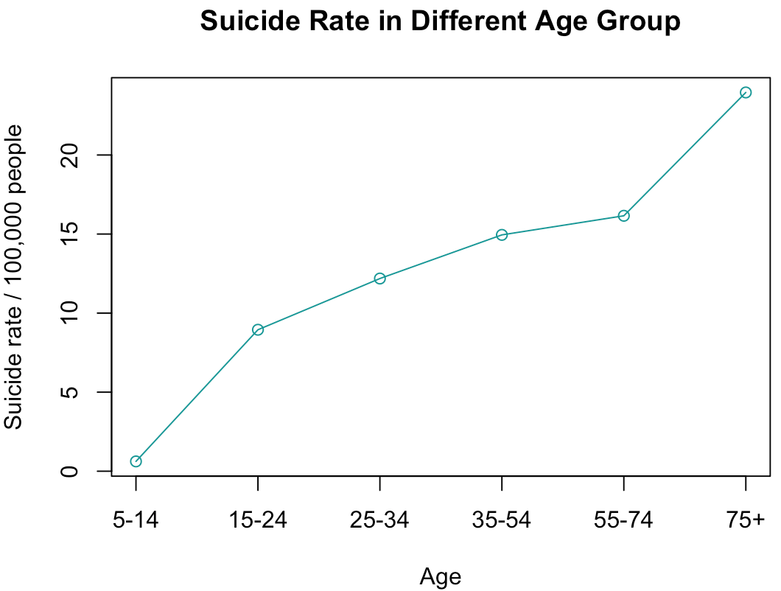

1. Why age and suicide rate has positive correlation? Is it the same for both genders?





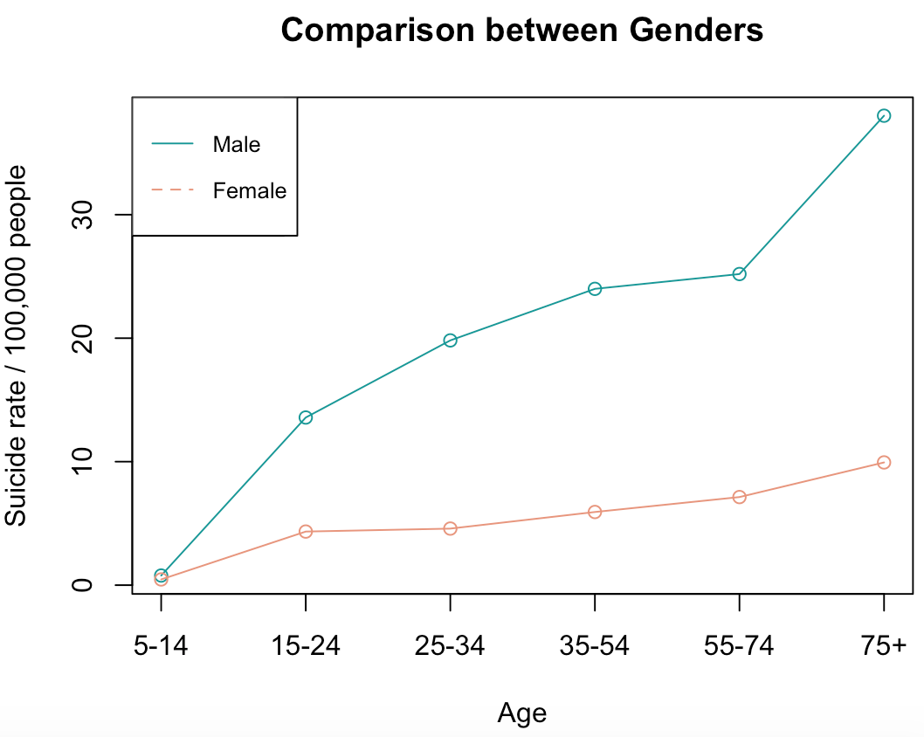

Yes, same pattern appears on both gender. But under comparison we can see that male has a sharper increase among ages. For kids from 5 to 14, there is not much difference between genders on suicide happening rate.

1. Same age group under different historical background, is there any changes

I subset the whole data into three decades: 1985 to 1995, 1996 to 2005 and 2006 to 2016.

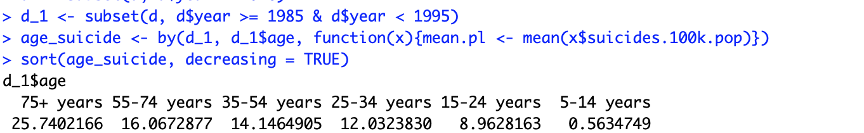

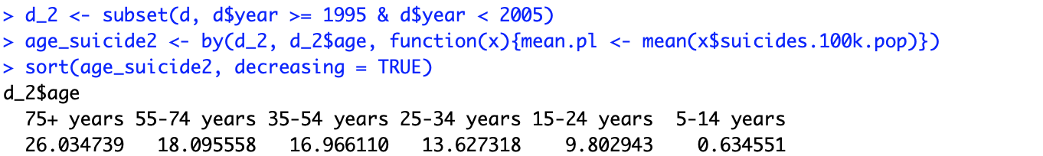

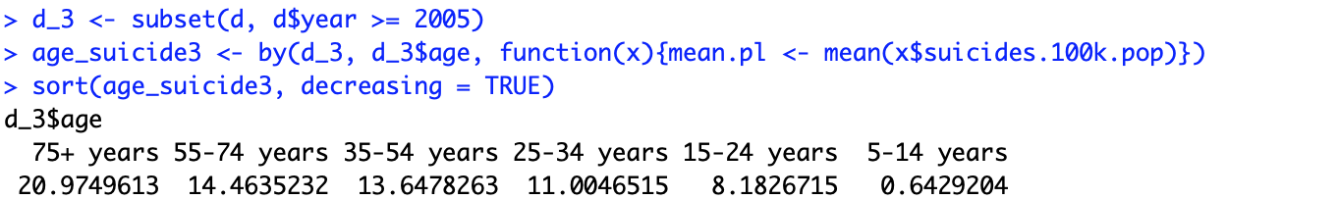

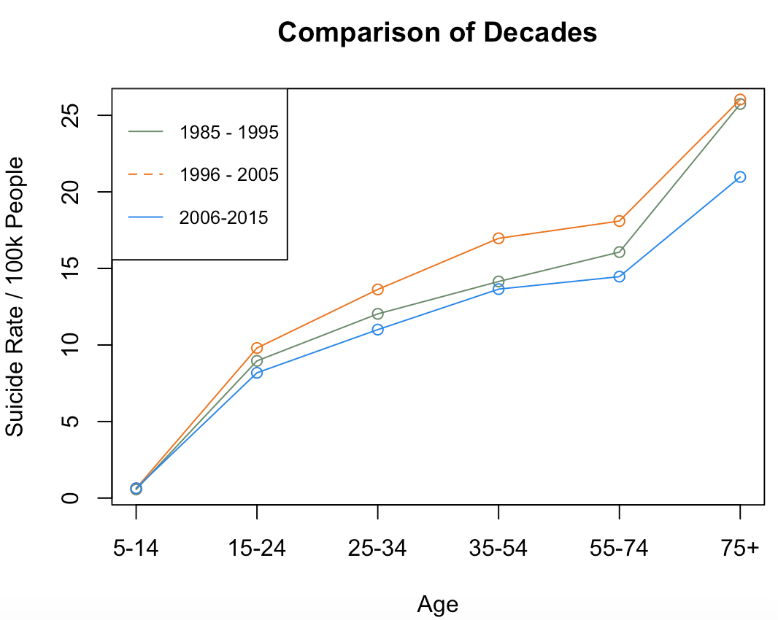

Yes, same pattern appears on all three decades. And the comparison between those decades shows 2006 through 2015 are the overall lowest suicide rate among all three decades and 1996-2005 shows highest.

**About year:**

1. What is the changing trend for suicide rate from 1985 to 2016?

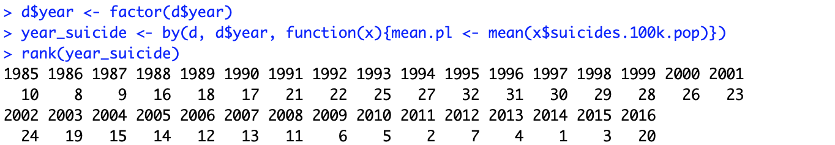

Looks like from 1985 to 2016, we can see the rough trend is that the suicide rate increased from 1985 to 1995 and then started to decrease to 2015. After looking though the dataset, there are a lot of country missing 2016 data. So I remove year 2016 from the dataset.

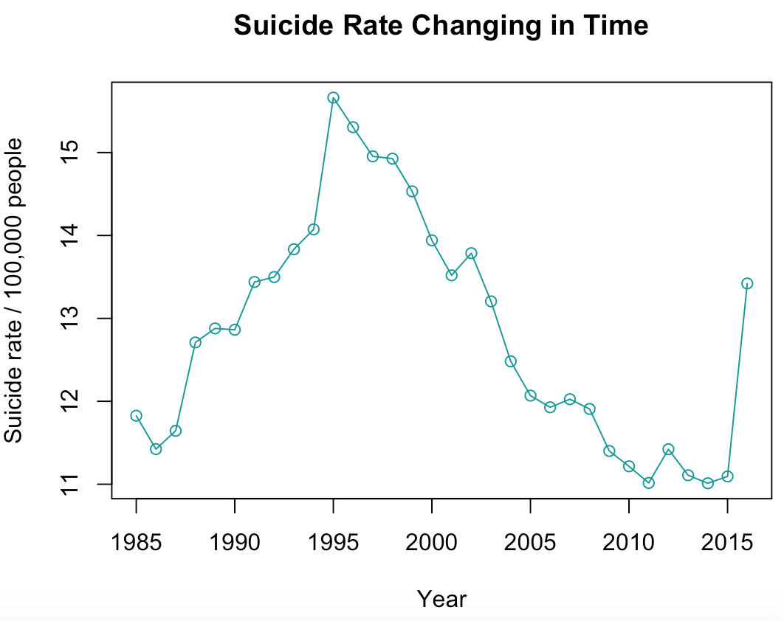 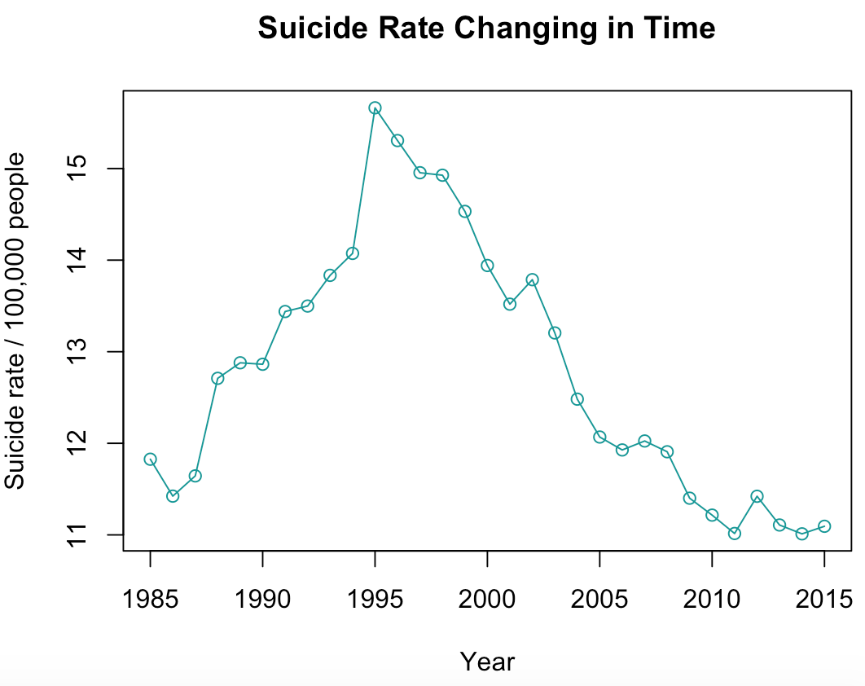

Then if subset whole population into two genders groups, we can see overall trend for women starting from 1996 is decreasing and fluctuating between 1985 and 1996.

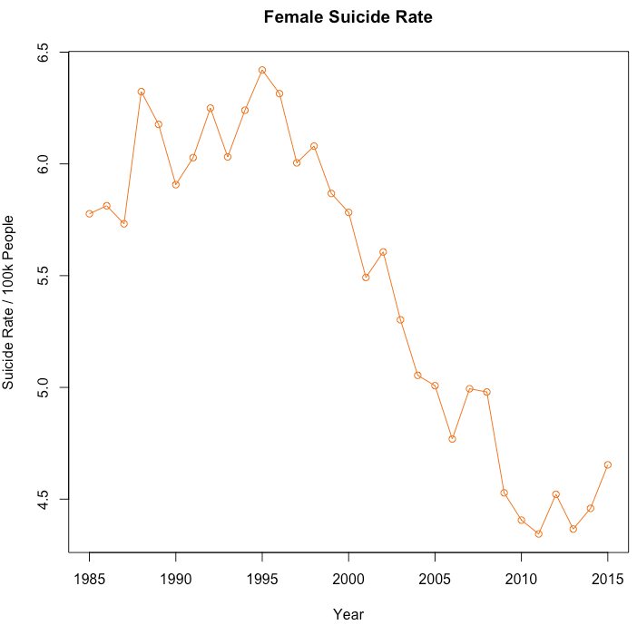 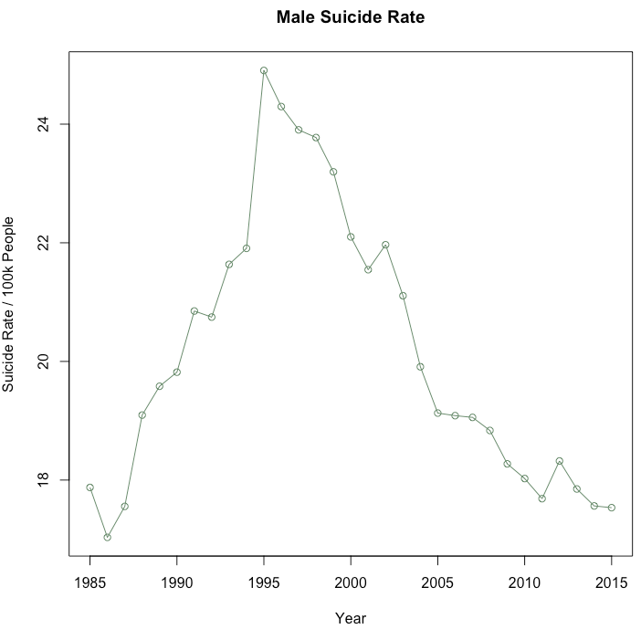

Then I plot the GDP changing over time (below chart). According to the below chart we can see that the economy is overall growing over time. From 1985 to 2000, the economy was growing slowly comparatively speaking, and from 2000 to 2015 the overall trend is growing rapidly. From above chart we can see that women suicide rate decrease when the economy grows rapidly. While from 1985 to 2000, when the economy growth speed is slow, women suicide rate was fluctuating. However, on the other hand, when the economy slowly grows from 1985 to 1996, men’s suicide rate was kept increasing over years. And then after economy starts to grow fast, men’s suicide rate started to drop and share the same pattern with women. But what noticeable is that starting from 1996, both genders suicide rate begins to drop.

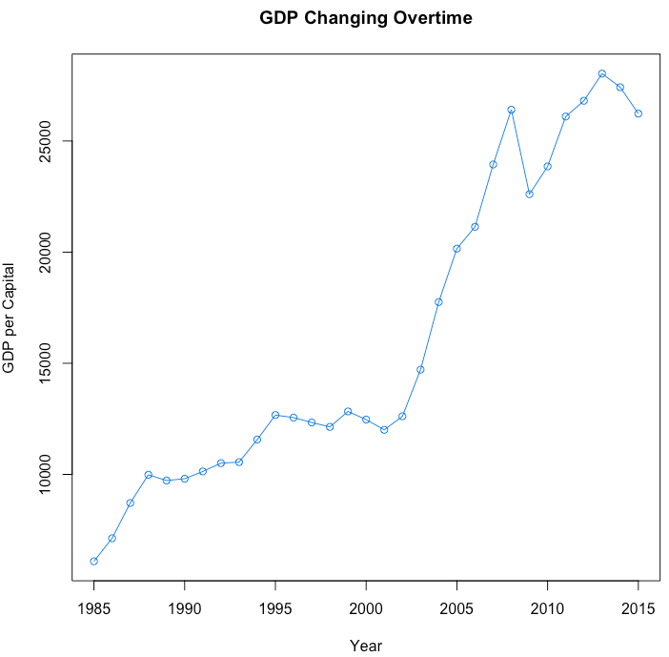

**About GDP:**

1. Is there correlation between GDP and suicide rate?



The correlation is very low for the whole population in this dataset.

1. Top 3 suicide rate countries suicide rate ~ GDP







Top 3 high suicide rate countries has negative correlation for economic growth and suicide rate. But still not significant.

**About genders:**

1. Comparison between genders

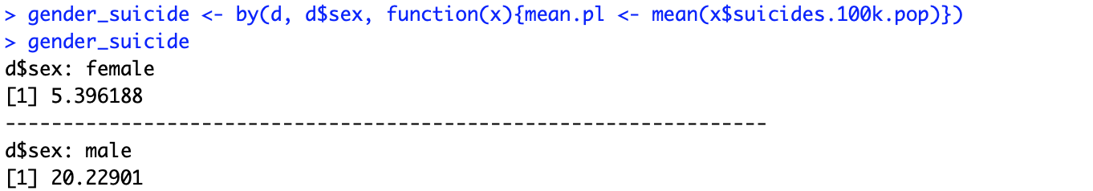

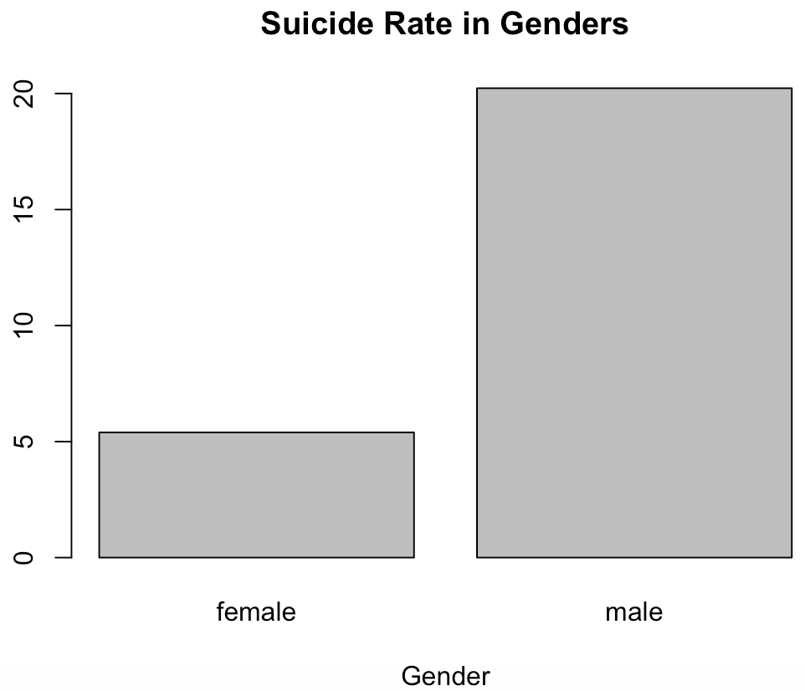

With same number of people in each gender, male suicide rate is about 3.75 times of female’s.

1. Are man and women take their life for same reason?

First sub set data into Female and Man, and only pick year, age, suicide rate, GDP/year and GDP/capital as variances. First chart is the linear model for all female in the dataset. Between age 25 and 34, female age does not affect suicide rate significantly. GDP for year and GDP per capital both have significant effect on women’s suicide rate. Then I subset data into male group, all age groups effect significantly on males’ suicide. However, the GDP per capital does not significantly explain males’ suicide rate at all.

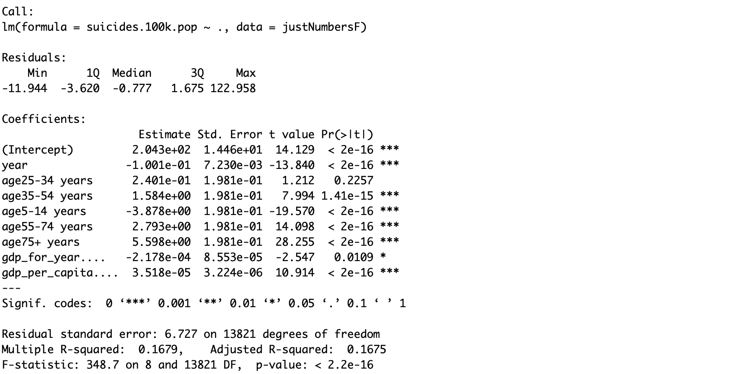

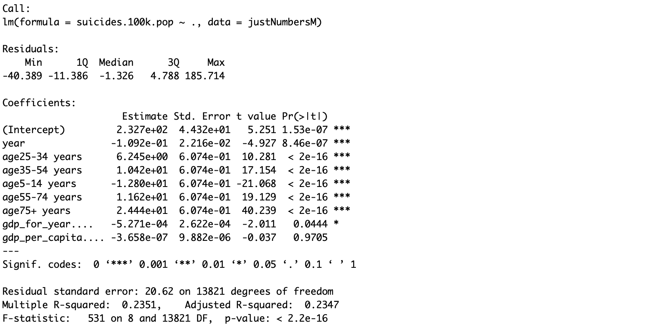

So we can conclude the reason for different gender to kill themselves are different in some aspects. Which also explained that although the economy is growing over time, unlike women suicide rate decrease accordingly, men’s suicide rate trend shows increasing over years from 1985 to 2000, when the economy growth speed is slow. Seems like men are under more pressure when there is a period of time when economy growth speed is not that good.